UNIT-1 MINI PROJECTS

1. AI Personal Knowledge Management System
An AI Personal Knowledge Management System helps users collect, organize, store, search, and retrieve notes, documents, PDFs, and learning resources efficiently.

Tools We Can Use
- Notion AI
- Obsidian
- Google Drive

Working :
- User uploads notes and documents.
- AI categorizes the content.
- AI generates summaries.
- User searches using keywords.
- AI retrieves relevant information.
Features
Smart Note Organization
AI-Based Summarization

Example
A student uploads Machine Learning notes and research papers. AI organizes them and provides summaries when searched.
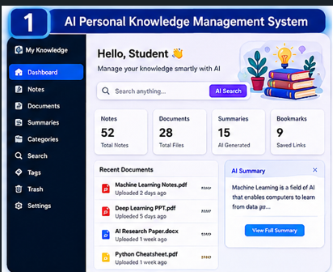

2. AI Learning Portfolio Builder
An AI Learning Portfolio Builder creates a digital portfolio to showcase projects, certificates, skills, and achievements.

Tools We Can Use
- Canva
- LinkedIn
- Kickresume
- ChatGPT

Working
- User enters project and certificate details.
- AI generates descriptions.
- Portfolio sections are created.
- Portfolio is displayed professionally.
Features:
• Certificate Management
• Project Showcase

Example
A student adds Python and AI certificates. AI generates a professional portfolio page.
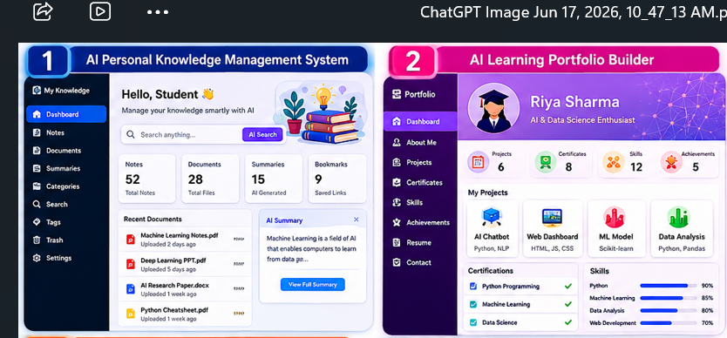

3. AI Career Advisor
An AI Career Advisor recommends suitable careers based on a user's skills, interests, and education.

Tools We Can Use
- ChatGPT
- LinkedIn
- Coursera
- Google Gemini

Working
- User enters skills and interests.
- AI analyzes the information.
- Career options are suggested.
- Required courses and certifications are recommended.
Features:
• Career Recommendations
• Skill Gap Analysis

Example
A Computer Science student receives recommendations for Data Scientist and AI Engineer careers.
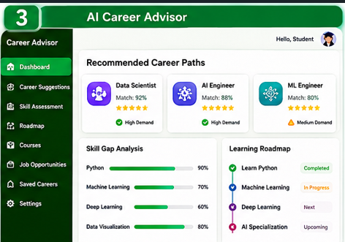

4. AI Productivity Dashboard
An AI Productivity Dashboard helps users monitor tasks, schedules, goals, and productivity.

Tools We Can Use
- Todoist
- Google Calendar
- Motion
- Power BI

Working
- User adds tasks and goals.
- AI prioritizes tasks.
- Dashboard displays schedules.
- Progress is tracked automatically.
Features:
• ask Management
• Goal Tracking

Example
AI creates a daily study plan and tracks assignment completion.
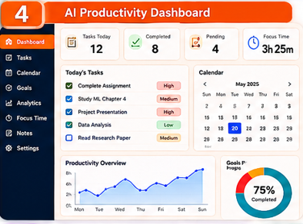

5. AI Research Assistant
An AI Research Assistant helps collect, summarize, and organize research information.

Tools We Can Use
- Elicit
- ResearchRabbit
- Zotero
- ChatGPT

Working
- User enters a research topic.
- AI finds relevant papers.
- AI summarizes the papers.
- References are organized automatically.
Features:
• Research Paper Discovery
• AI Summarization

Example
Research papers on Quantum Computing are collected and summarized.
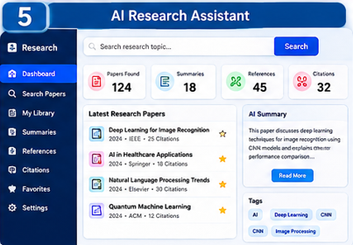

6. AI Academic Planner
An AI Academic Planner helps students organize classes, assignments, exams, and study schedules.

Tools We Can Use
- Google Calendar
- Motion
- Todoist
- ChatGPT

Working
- Student enters subjects and exam dates.
- AI creates a timetable.
- Study sessions are scheduled.
- Reminders are generated.
Features:
• Study Timetable Generation
• Assignment Tracking

Example
AI creates a weekly exam preparation schedule.
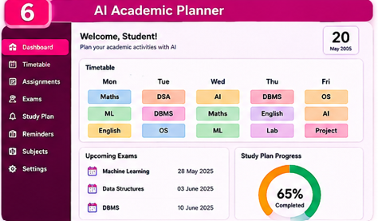

7. AI Study Companion
An AI Study Companion assists students in learning, revision, and doubt clarification.

Tools We Can Use
- ChatGPT
- Quizlet
- Khan Academy
- Google Gemini

Working
- Student enters a topic.
- AI explains concepts.
- Practice questions are generated.
- Revision notes are provided.
Features:
• Concept Explanation
• Quiz Generation

Example
AI explains Neural Networks and generates quiz questions.
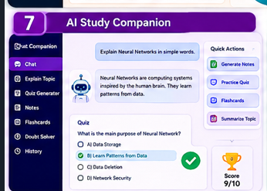

8. AI Knowledge Repository
An AI Knowledge Repository stores and manages AI-generated notes, reports, and summaries.

Tools We Can Use
- Notion AI
- Obsidian
- Google Drive
- ChatGPT

Working
- AI-generated content is stored.
- Resources are categorized.
- Search functionality is provided.
- Information can be retrieved anytime.
Features:
• Knowledge Storage
• Resource Categorization

Example
Store AI-generated summaries for all subjects in one repository.

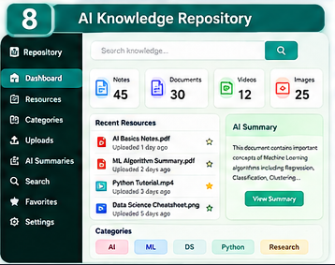

9. AI Learning Analytics System
An AI Learning Analytics System analyzes learning activities and visualizes performance.

Tools We Can Use
- Power BI
- Google Looker Studio
- Microsoft Excel
- ChatGPT

Working
- Learning data is collected.
- AI analyzes study habits.
- Charts and reports are generated.
- Suggestions are provided.
Features:
• Learning Progress Tracking
• Performance Analysis

Example
AI shows weekly study hours and course completion percentage.
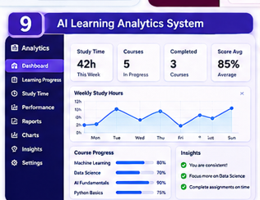

10. AI Productivity Assistant
An AI Productivity Assistant helps users manage tasks, schedules, reminders, and daily activities.

Tools We Can Use
- Todoist
- Google Calendar
- Motion
- ChatGPT

Working
- User enters tasks.
- AI prioritizes tasks.
- Reminders are scheduled.
- Progress is tracked.
Features:
- Task Scheduling
- Reminder Management
- Time Management Assistance

Example
AI reminds a student about assignment deadlines and study sessions.

